**Practical File**

**Of**

**Problem Solving using**

**Python Programming**

**23CS001**

***Submitted***

***in partial fulfilment for the award of the degree***

# of

**BACHELEOR OF ENGINEERING**

***in***



COMPUTER SCIENCE & ENGINEERING

**CHITKARA UNIVERSITY**

**CHANDIGARH-PATIALA NATIONAL HIGHWAY RAJPURA (PATIALA) PUNJAB-140401 (INDIA)**

December, 2023

**Submitted To: Submitted By:**

Dr. Preeti Sharma Aneet Kaur

Teacher 2310992594

Chitkara University, Punjab 1st semester,2023

# INDEX

|  |  |  |
| --- | --- | --- |
| **Sr.**  **No.** | **Practical Name** | **Teacher Sign** |
| 1 | Write a Python Program to Calculate the Area of a Triangle. |  |
| 2 | Write a Python Program to Swap Two Variables. |  |
| 3 | Write a Python Program to Convert Celsius to Fahrenheit. |  |
| 4 | Write a Python Program to Check if a Number is Odd or Even. |  |
| 5 | Write a Python Program to Check if a Number is Positive, Negative or 0. |  |
| 6 | Write a Python Program to Check Armstrong Number. |  |
| 7 | Write a Python program to check if a given number is Fibonacci number? |  |
| 8 | Write a Python program to print cube sum of first n natural numbers. |  |
| 9 | write a Python program to print all odd numbers in a range. |  |
| 10 | Write a Python Program to Print Pascal Triangle. |  |
| 11 | write a program to draw the following Pattern for n number. |  |
| 12 | Write a program with a function that accepts a string from keyboard and create a new string after converting character of each word capitalized. For instance, if the sentence is “stop and smell the roses” the output should be “Stop And  Smell The Roses” |  |
| 13 | Write a program that accepts a list from user. Your program should reverse the content of list and display it. Do not use reverse () method. |  |
| 14 | Find and display the largest number of a list without using built-in function max ().Your program should ask the user to input values in list from keyboard. |  |

**Program 1:**  Write a Python Program to Calculate the Area of a Triangle.

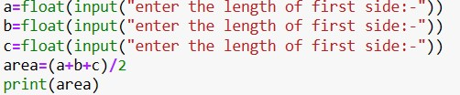

**Output:**

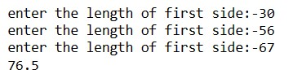

**Program 2:** Write a Python Program to Swap Two Variables.

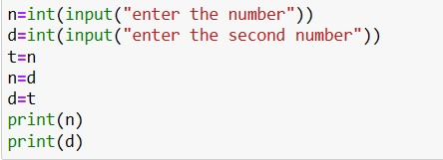

**Output:**

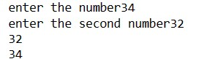

**Program 3:**Write a Python Program to Convert Celsius to Fahrenheit.

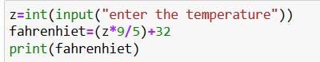

**Output:**



**Program 4:**Write a Python Program to Check if a Number is Odd or Even

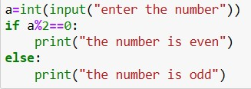

**Output:**



**Program 5:**Write a Python Program to Check if a Number is Positive, Negative or 0.

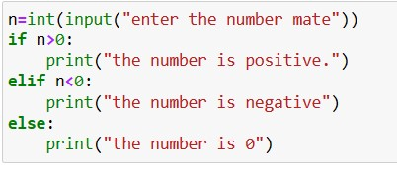

**Output:**

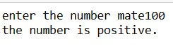

**Program 6:**Write a Python Program to Check Armstrong Number.

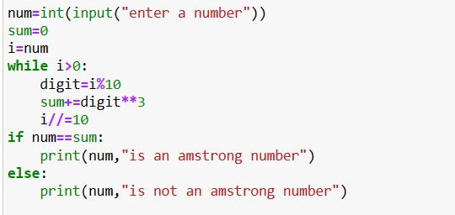

**Output:**



**Program 7:**Write a Python program to check if a given number is Fibonacci number?

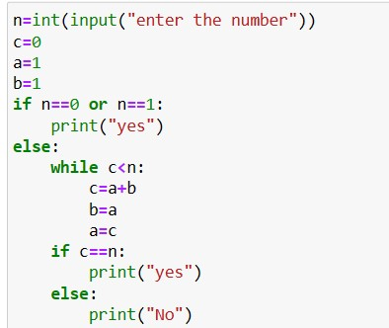

**Output:**



**Program 8:** Write a Python program to print cube sum of first n natural numbers.

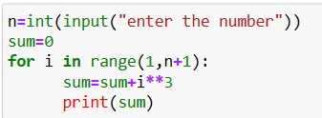

**Output:**

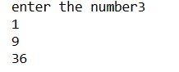

**Program 9:** write a Python program to print all odd numbers in a range.

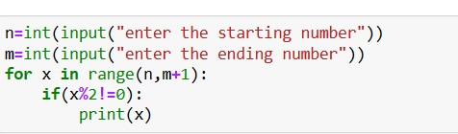

**Output:**

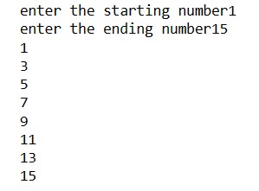

**Program 10:**Write a Python Program to Print Pascal Triangle.

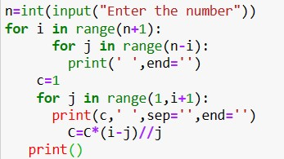

**Output:**

**Enter the number :4**

**1**

**1 1**

**Program 11:** write a program to draw the following Pattern for n number.

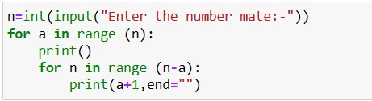

**Output:**

**Enter the number:4**

**11**

**1122**

**Program 12:** Write a program with a function that accepts a string from keyboard and create a new string after converting character of each word capitalized. For instance, if the sentence is “stop and smell the roses” the output should be “Stop And Smell The Roses”

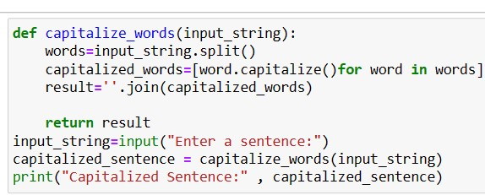

**Output:**



**Program 13:** Write a program that accepts a list from user. Your program should reverse the content of list and display it. Do not use reverse () method.

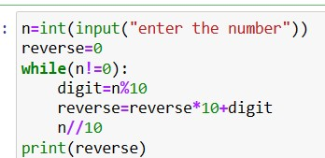

**Output:**

**Enter your number:4567**

**7654**

**Program 14:** Find and display the largest number of a list without using built-in function max (). Your program should ask the user to input values in list from keyboard

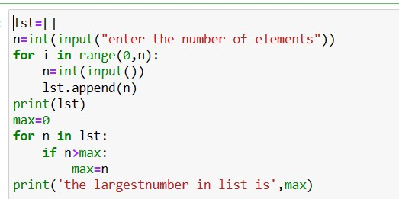

**Output:**

**Enter the elements:5**

**56**

**445**